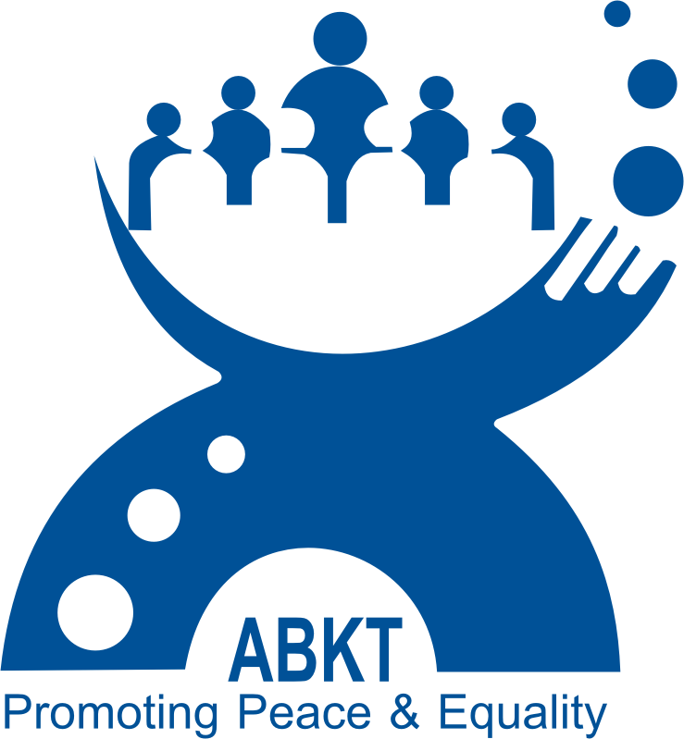“Call for Young Emerging Leaders from Khyber Pakhtunkhwa and FATA”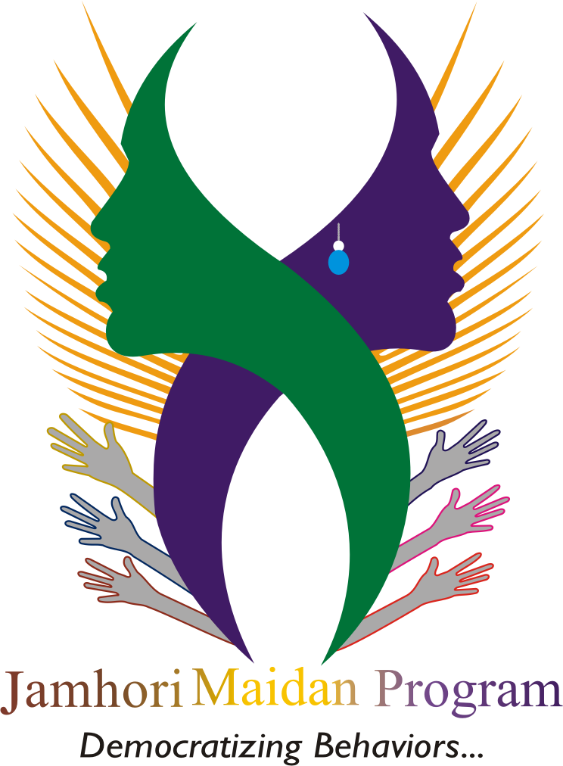

Democracy, peace and the protection of human rights are fundamental prerequisite toinstitute and ensure a peaceful, progressive and just society. The basic set of human rights as defined by the United Nations Charter on Human Rights which includes economic, social and political rights is are natural and innate. No boundariescan limit human dignity and equal respect. The desire for freedom, democracy and security is universal and collective.

Association for Behaviour and Knowledge Transformation (ABKT)is a national non-profit development organization striving to improve the socio, economic and political empowerment ofcommunities in the under-served areas of Khyber Pakhtunkhwa and FATA through capacity development, political empowerment and leadership development. Women, youth and marginalized groups are the main focus of ABKT programs and projects.

ABKT is currently implementing “Jamhori Maidan Project” in KPK and FATA. The objective of the project is to ‘Strengthened democratic system; inclusive of women & youth in Khyber Pakhtunkhwa and FATA’. Under this project ABKT is announcing a “Call for Young Emerging Leaders”from Khyber Pakhtunkhwa and FATA.The Young Emerging Leaders would be provided a training on ‘Peace,Democracy, Human Rights &social work’ to act as a Leaders of Change.
Pakistani Youth of 18 to 30 living in Khyber Pakhtunkhwa (Nowshera, Charsadda, Mardan, Swabi, Swat, Shangla, Buner, Malakand, Upper Dir & Lower Dir) and FATA (all agencies) are eligible to apply.
Selection Criteria:
- Youth from all section of society irrespective of sex, race, religion and language are encouraged to apply.
- Must be between the age of 18-35years
- Must be from these areas:
- Khyber Pakhtunkhwa (Nowshera, Charsadda, Mardan, Swabi, Swat, Shangla, Buner, Malakand, Upper Dir & Lower Dir)
- FATA (all agencies)
- The candidates will be shortlisted based on their training requirement, experience (activism passion) & gender equality for trainings.
Applicants should apply till Tuesday 20thJuly 2015.
Note: ABKT is an equal opportunity organization. Only short listed candidates would be informed about the interview.
Interested candidates should send a copy of their CNIC along with the answers to the Questionsbelow on abkt.pakistan@gmail.com
Registration Form for Young Emerging Leaders (YEL)

- Name: _______________________________________
- Age: ________________________________________
- CNIC: _______________________________________
- Education: ___________________________________
- Gender: _____________________________________
- Area/location: ________________________________
- Phone number: ______________________________
- Email: _____________________________________
- How do you define peace and democracy in your own words? (Word limit 200 words)
- What are the main problems related to peace democracy and human rights in your area? (limit 250 words)
- What do you expect from this training? How can it help you?
- Have you ever participated in the social youth forums (any)?
- No
- Yes, (If yes, Please mention the name)
- How will you use the skills and techniques acquire from this training for improving the ground situation in your area?

